Statistics Lecture 4.5: Probability of Complementary Events with "At Least One

“At Least One” - One or more
Complement of “At least one” is zero.

P(“At Least One”)=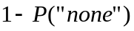

Example
Flip coin 3 times. What is the probability of getting at least 1 head?
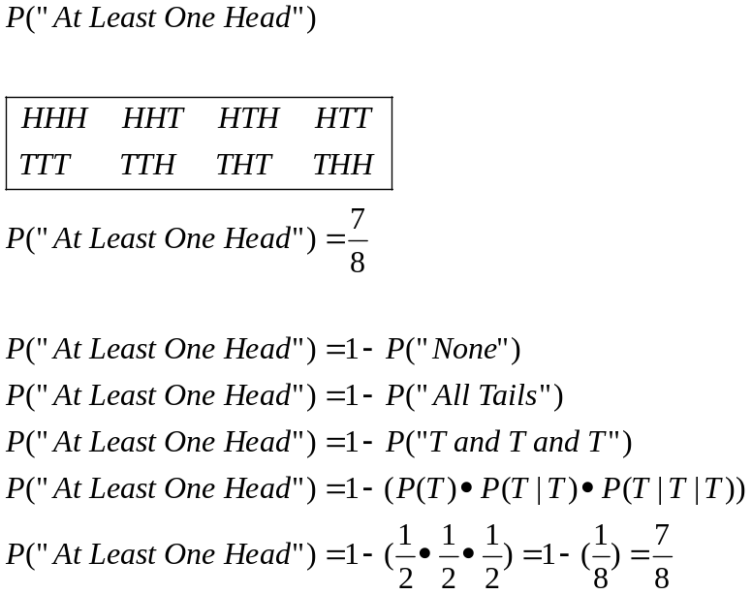

Example:
1) Rolling a die. (independent)
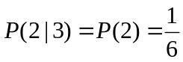
Rolled a 3 then rolled a 2.

- Drawing cards
With replacement 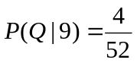 independent
Without replacement 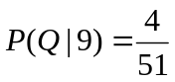 dependent

With replacement 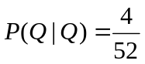 independent
Without replacement 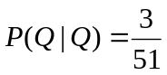 dependent

